

Project Report

Course Title: OS Lab

Course Code: CSE324

Project Title: Fast Food Restaurant Management System in Shell Script

Submitted To

**Ms. Subhenur Latif**

Assistant Professor in Dept. of CSE

Daffodil International University

Submitted By

Md. Musfiqur Rahman Foysal

ID: 163-15-8489

Section: O-1

Submission Date: 15-08-2020

Abstract

It’s a small restaurant. Practically, customers have to make their order by choosing food from our given food menu list. This is a simple shell script based project. After taking orders we provide the bill to the customers and customers has to pay the bill and wait for collecting the food. After taking the order customers receives a greeting message. Conclude that insist of the program cause more efficiency to the restaurant.

Table of Content

Chapter-1

* Introduction.

Chapter-2

* Project Demonstration and Explanation
* Demonstration Examples
* Code Discussion

Chapter-3

* Usages in Real Life
* Advantages
* Disadvantages
* Limitations

Chapter-4

* Future Possibilities & Improvement.

Chapter-5

* Conclusion

**Chapter-1**

**Project Title**

Fast Food Restaurant Management in Shell Script. In a restaurant, the food order contains food name, size, and quantity.

**Introduction**

The project requires to make a program which will help to automate the process of food order and delivery system in a restaurant. The program will ask customer to enter the food he/she want to take from a given list. Then will ask to enter the desired quantity of that item. After getting the order customers get a greeting message and get an inform message for paying the bill and wait for collecting the food.

**Difficulty**

Medium

**Input**

The program will take input for choosing option from menu. Then will engage according to the selection.

**Order:** Choosing order will show the list of food items and ask to input number of items to order. After selecting this it will ask for chosen items then for every item it will ask for the size of the item (if available). After entering of size of the item it will ask for the quantity of the item. After the requested input, the order will complete showing a message containing customer’s bill for paying and also a greeting message.

**Output**

Output will show the total bill amount which a customer ordered and which will need to pay.

**Language(s) used**

The complete program is written in Shell Script. Which is called Bash Programming.

**IDE used**

Linux OS Terminal.

**Testing and Validation**

The program was tested using many of different inputs needed accordingly to see the outputs. And the program successfully delivered the desired output at any time of command.

Program was run several times with different inputs by coder.

Chapter-2

**Project Demonstration and Explanation**

**Demonstration Screenshots:**

**Example 1:**

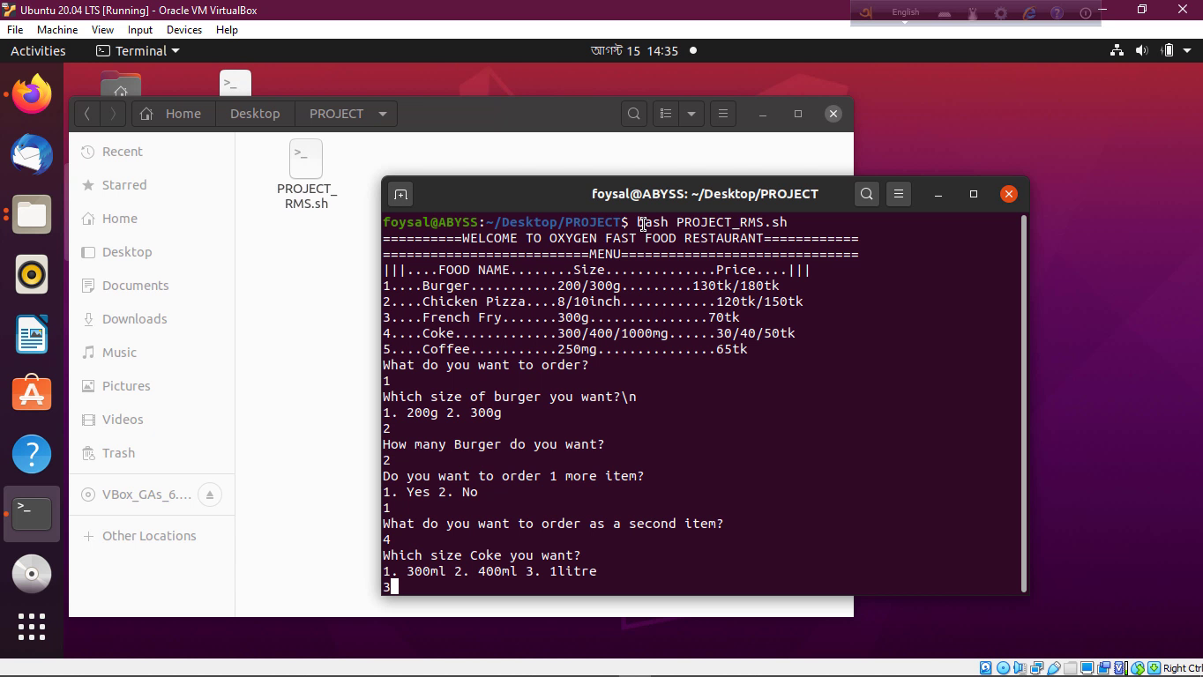

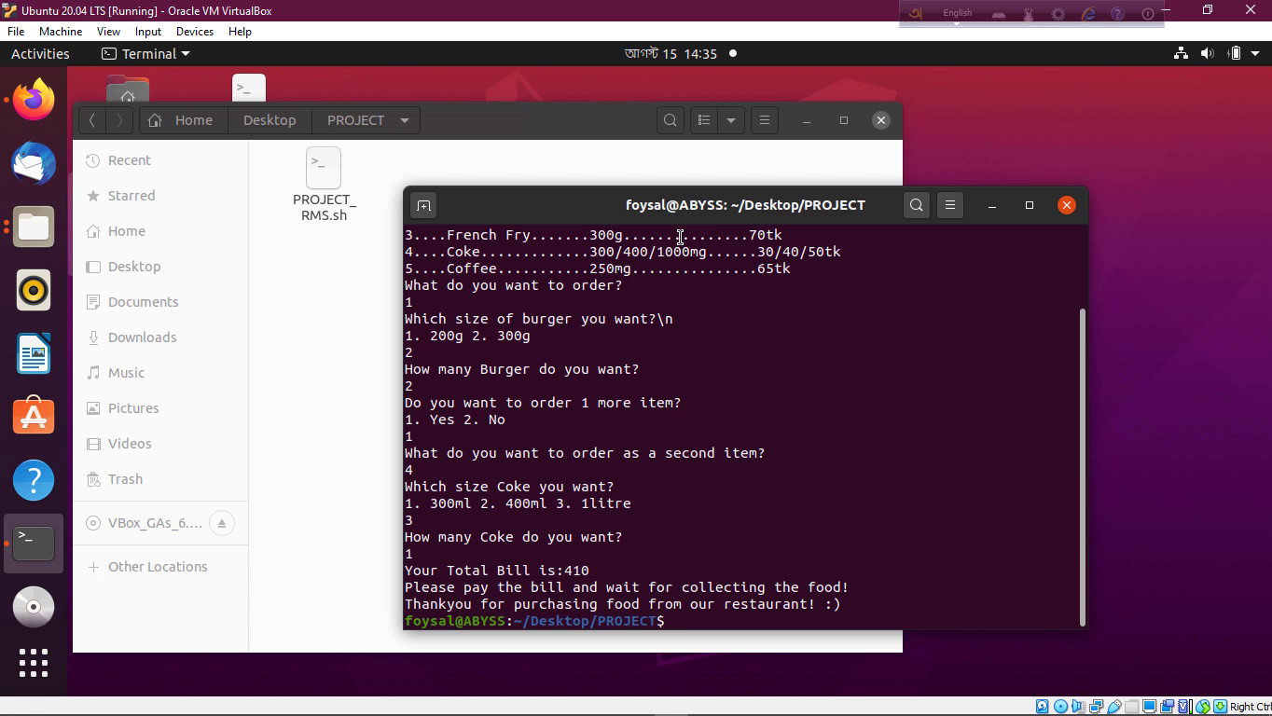

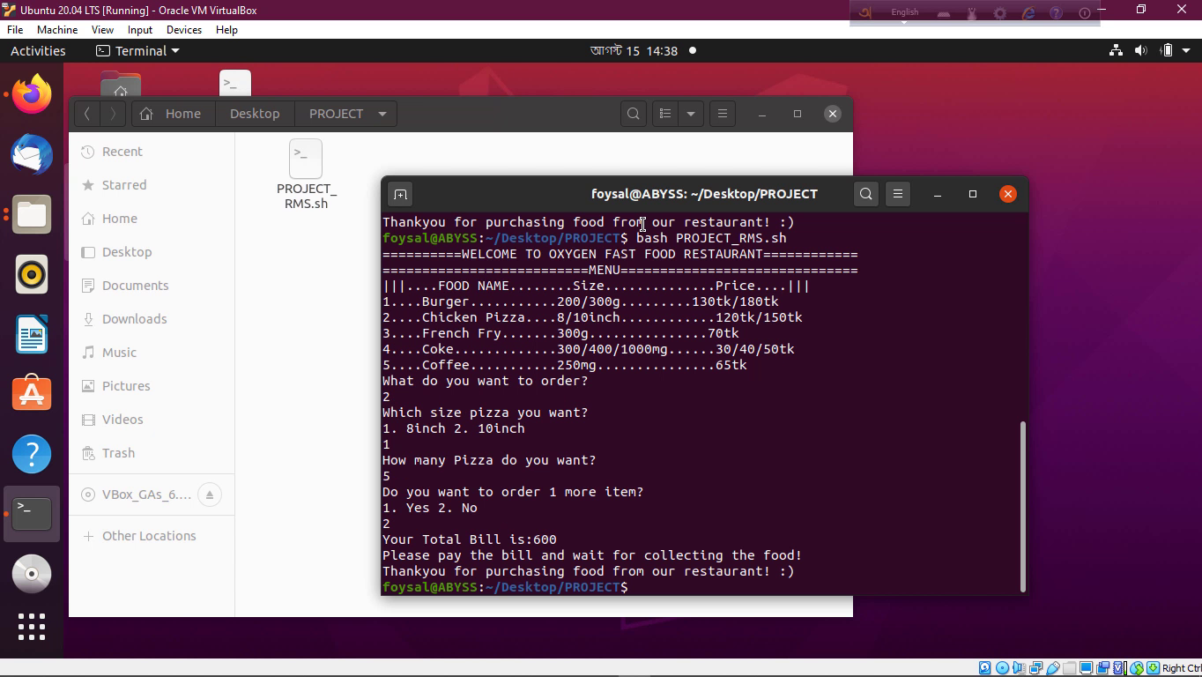

**Working Procedure:**

**Example 1:**

At first run of the program it will show the welcome message with the name of restaurant and a food menu list which will have order by a customer. The food menu is consist of food name, size and prize.

Then it will ask for an order. Here 5 item of food is available so he/she has to select 1-5 any food for ordering. In example 1, we selected 1 or Burger and then it will ask for the size of the burger with the message 1. 200g 2. 300g. Then it will ask for the quantity of the burger for order. We selected 300g size burger and quantity of 2. Then the program will ask for another order. Here we select yes and it will ask for the item name of second order. We select coke which is no 4 food. Then it will ask for the size of the coke bottle with the different size of the bottle. Then we select 1 litre coke.

After completing the order it will show the total bill amount. And the inform message for paying the bill and wait for collecting the food. After it will also show a greetings message.

**Example 2:**

The process of order is same as example 1 but here the difference is when we complete our first order then it will ask for the second order. Then we select for No. Then directly show the total bill of first order with inform message and the greeting message.

**Project Explanation Screenshots:**

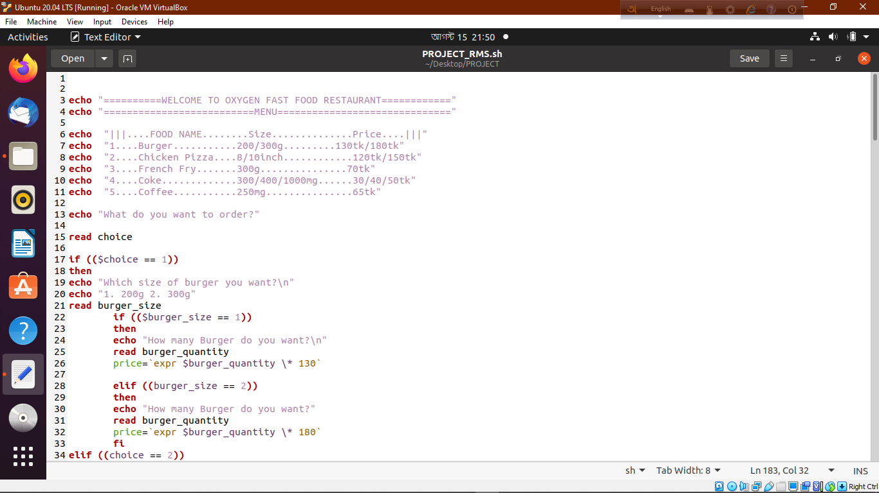

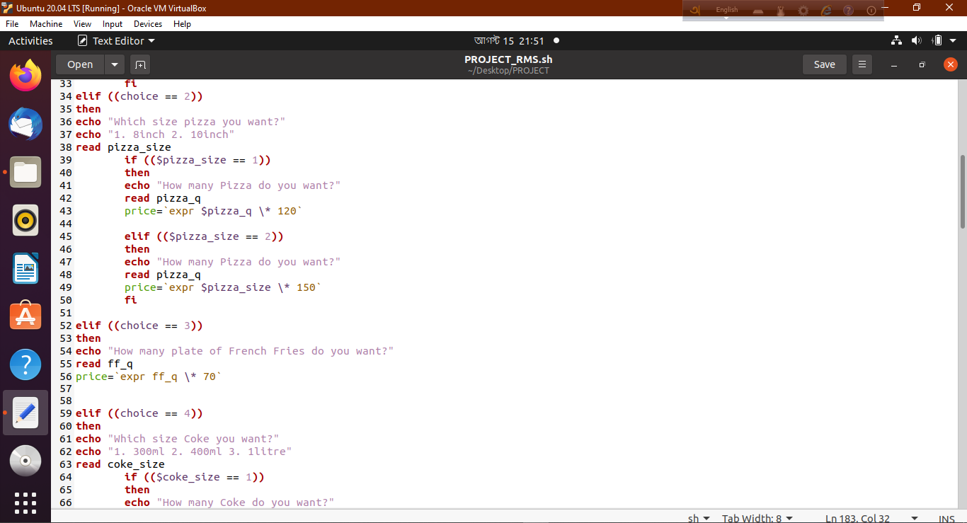

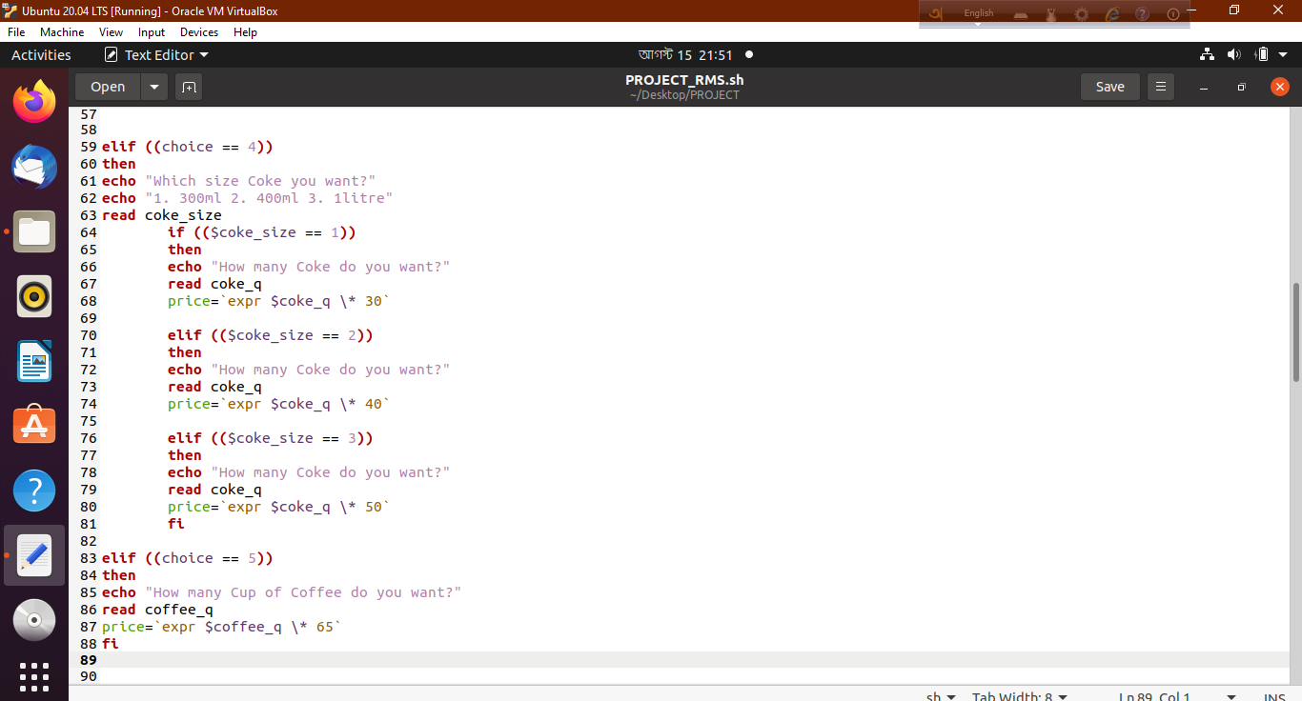

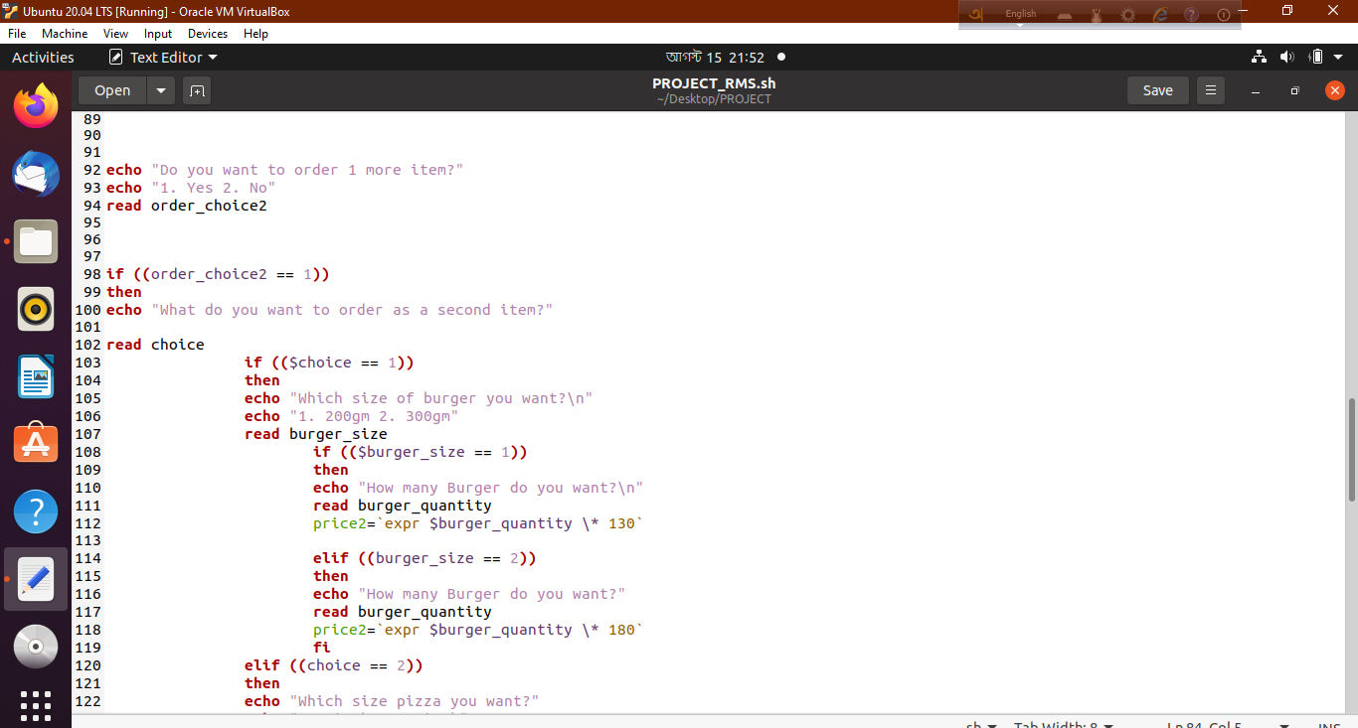

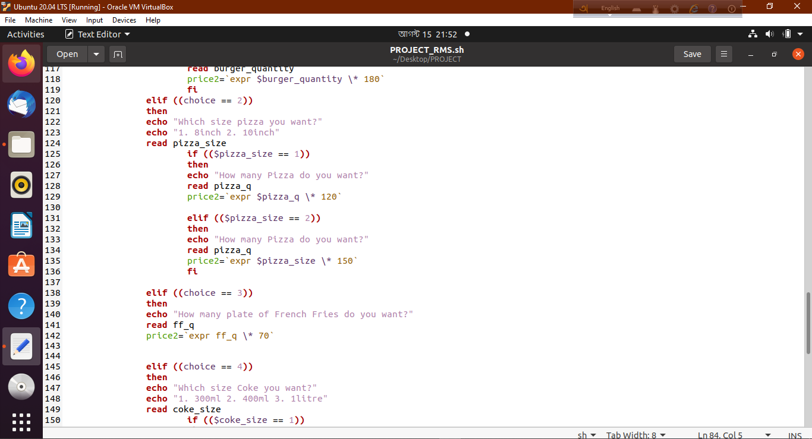

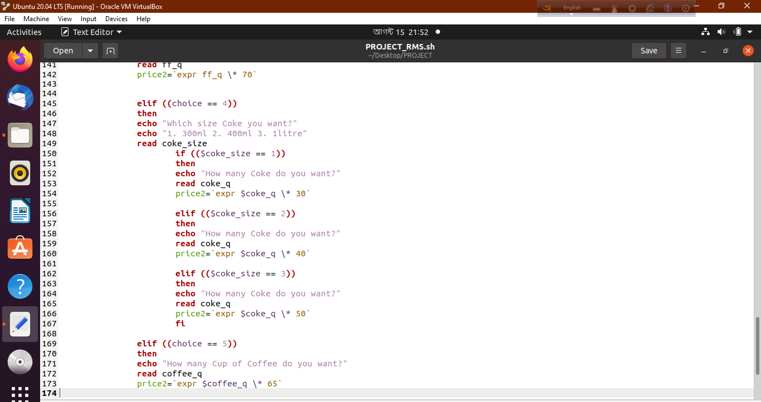

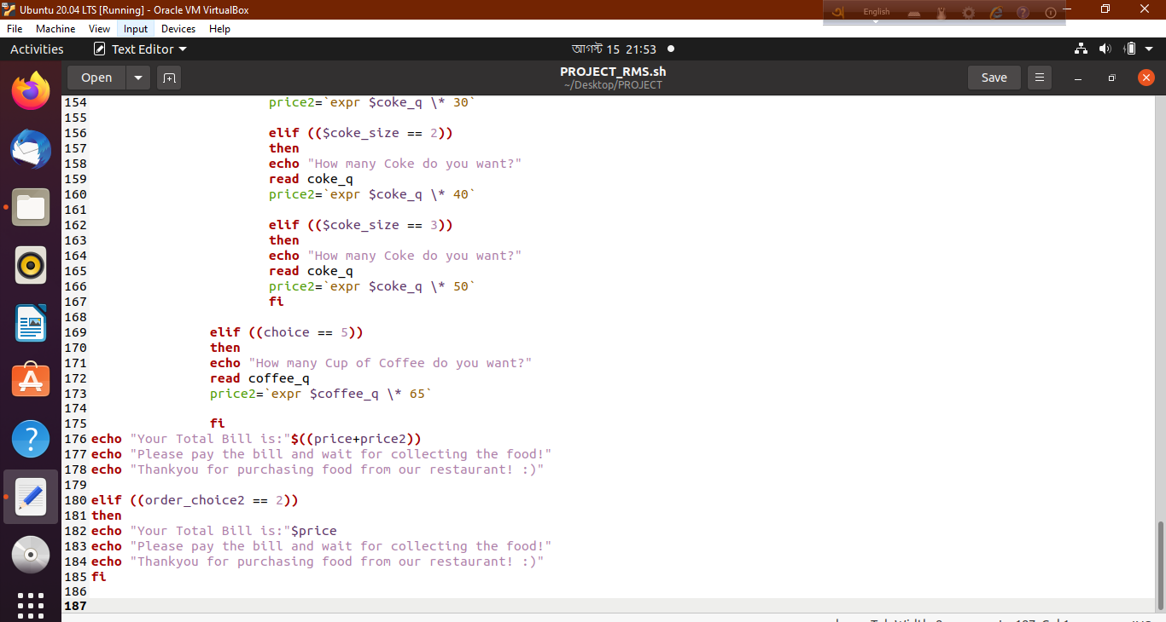

**Working Procedure:**

In the first of the programme we have displayed the restaurant name, menu details and menu list by using the echo. After using this display we used read function for taking order choice input from the customer. Here we have 5 available food in the list. So a customer have to select between 1 and 5 for order the food. After getting of choice input value then if function will work here. In the first condition where burger or 1 choice value, here it will print a message for getting the size of the burger. And also here can be the different input value as menu. So here we have used a nested if function. After getting the size of the burger it will ask for the quantity of the burger. Here we have used if and elif. After getting the size and the quantity we have calculated the price in a variable with the expression multiplication function.

By using of elif we have work all the statement same before.

In the second order system we have just used a nested if function for getting the second order. We have asked the customer for the second order. If he input yes then the previous whole if elif function will run again. In the end of the second order function run it will calculate the total bill in a new variable with summation of the previous bill amount and second bill amount. And also it will show the message of information for paying the bill and wait for the food. Also it will show a greeting message to the customer.

If the customer input no for the second order. It will only calculate the first order bill and the other messages.

**Chapter-3**

**Usage in Real Life**

This program can be used in Food courts or restaurants to maintain the food orders and keep everything under surveillance. Although this program contains a few items in list the list can be bigger and with more options as necessary.

**Advantages**

This program will help restaurants to manage food orders more easily. Busy shops have calculating exact bill problems sometimes. This program will help to maintain the accurate bill for customer within fastest time.

**Disadvantages and Limitations**

This program is a console program which is not user friendly. The interface is quite difficult to input data normally. This program has a small size of food menu which will not enough for good business. So we need to develop this program with more food items.

Chapter-4

**Future Possibilities and Improvements**

Upgrading this program, we can create more suitable food management system. Which can even be capable of keeping records of previous records. Adding a user-friendly GUI can make this program usable by everyone. It can more item list than it has in it. With a few adjustments, we can even make a way to change any order that has already been placed. It will bring a little complexity to source code but will surely be helpful. This can be used in AI for automated home delivery system.

Chapter-5

**Conclusion**

This program is full of potential to help people managing orders and saving times. It can be helpful for both customers and restaurant owner or manager.

**References**

1. <https://www.shellscript.sh/>
2. <https://www.tutorialspoint.com/unix/shell_scripting.htm>
3. <http://linuxcommand.org/lc3_writing_shell_scripts.php>
4. <https://www.guru99.com/introduction-to-shell-scripting.html>
5. <https://www.javatpoint.com/shell-scripting-tutorial>
6. <https://linuxhint.com/30_bash_script_examples/>
7. <https://www.geeksforgeeks.org/introduction-linux-shell-shell-scripting/>

-0-